Analysis of the Impacts of Technology and Social Media on Mental and Physical Well-being.
BY: Atharva Bhushan Karekar


Syracuse University
ITS 686 M001 Spring 2025
PREPARED FOR : Professor Dilmore
5/8/2025

INTRODUCTION

In modern era, Technology is embedded in each and every individuals life. In this report we are going to discuss about the analysis between mental health and technological usage like how social media usage, screen time, and gaming and key indicators of mental and physical health, including stress levels, sleep patterns, and physical activity are related. The primary objective of this analysis is to determine whether digital behavior patterns are significantly associated with mental health outcomes and lifestyle factors. The findings aim to provide data-driven insights into how modern technology engagement may influence well-being. The report and the analysis is going to address questions such as
- Gaming and Social media usage can lead to poor Mental health.
- Is screen time related to stress level?
- Is there a relationship between technology usage hours and sleep duration?
- Is heavy social media usage associated with reduced physical activity?
- Is access to support systems associated with better physical activity or sleep patterns?
These questions are going to help us with the analysis and Impacts of technological usage on the mental as well as physical health.

DESCRIPTIVE OVERVIEW
This report presents a comprehensive statistical analysis of the between mental health and technology usage. This analysis consists of dataset for 10,000 individuals. The dataset includes a wide range of variables related to user demographics, technology engagement, and health indicators. Key numeric variables such as
- Social_Media_Usage_Hours
- Gaming_Hours
- Screen_Time_Hours
- Sleep_Hours
- Physical_Activity_Hour
- Support_System_access
These were summarized using measures of central tendency (mean, median) and dispersion (standard deviation, range). Most of the variables displayed a symmetric distributions and too low of an Impact on the mental health, But for Gaming_Hours and Screen_Time_Hours, exhibited moderate skewness and contained outliers on the higher end. These outliers may influence regression results and correlation coefficients, so they were carefully examined using boxplots.
To support the statistical analysis various visualizations were used including boxplots, line diagrams. The visualizations were mainly box plots and line diagrams as boxplots highlighted group differences and a 2d line diagram helped it make easier to read the graphs and understand those. These graphical tools, paired with statistical summaries, provide a clear and interpretable foundation for the inferential methods that follow.
INFERENTIAL ANALYSIS
This part of the report will contain the analysis such as plotting, t-test, Bayesian test, etc. Which will help us know the impact of technology usage on the mental as well as physical health, We will answer the research questions which will easily help to understand more about the analysis.
- Gaming and Social media usage can lead to poor Mental health?
Response variable: Mental_Health_Status.
Predictor variables: Social_Media_Usage_Hours, Gaming_Hours.
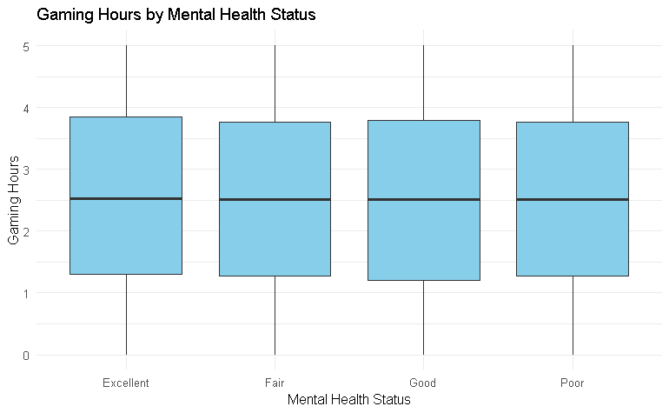
The plot shows the gaming hours across all the mental health status such as excellent Fair good and poor, All the observations are consistent with approximately 2.5 to 3 hours, There are no substantial shifts or patterns that suggest increased or decreased gaming is associated with worsening mental health. This visual observation suggests no significant difference in gaming behavior by mental health status.

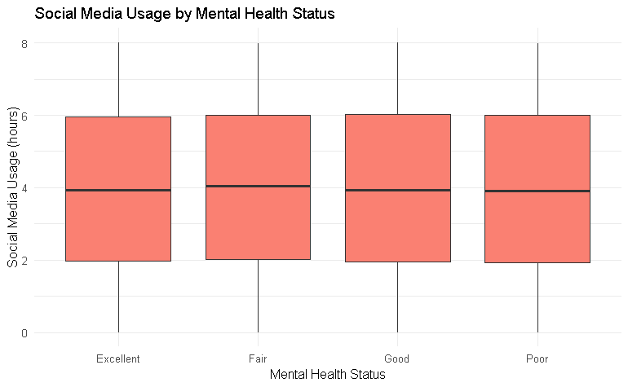
The plot displays social media usage hours across different mental health statuses: Excellent, Good, Fair, and Poor. Across all groups, social media usage appears highly consistent, with median values around 4 hours per day and comparable interquartile ranges. There are no notable shifts in usage levels across mental health categories, and the spread of the data is virtually identical. This suggests that increased or decreased social media usage is not clearly associated with better or worse mental health. This suggests no significant difference in social media use among mental health groups.
- One-way Frequentist annova testing for the both the variables :
The One way anova frequintist shows us that as the p values for both social media hours and gaming hours are are larger than 0.05 we see no statistically significant difference by both the variables on the mental health status as suggested by the plots earlier.

- BayesFactor for both the the variables:
The Bayesian ANOVA results reinforce this finding, with extremely small Bayes Factors BF = 0.00034 for social media usage and BF = 0.00022 for gaming hours providing overwhelming evidence in favor of the null hypothesis. In Bayesian terms, this means the data strongly support the idea that neither gaming nor social media usage meaningfully varies with mental health status in this dataset.

- Multinomial regression model for the both the variables :
The multinomial logistic regression model found that neither gaming hours nor social media usage hours significantly predict mental health status. All p-values were > 0.24, and the effect sizes (coefficients) were very small. This suggests that, in this dataset, variations in time spent gaming or on social media are not meaningfully associated with differences in reported mental health categories. These findings align with earlier ANOVA and Bayesian analyses, which also showed no significant relationships.

- Is screen time related to stress level?
Response variable: Stress_Level
Predictor variable: Screen_Time_Hours

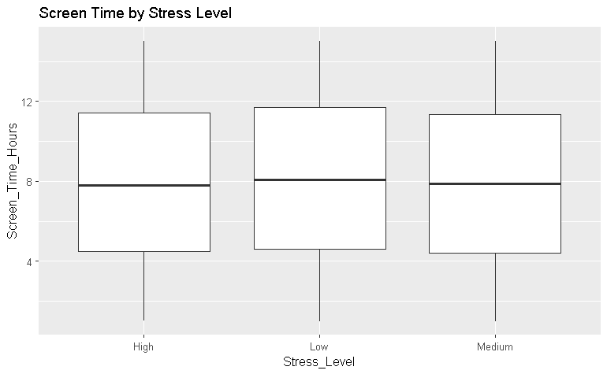
The following plot compares total daily screen time across three levels of reported stress such as low, medium, high. The median screen time is mostly same across all the stress levels, However higher stress level shows a slightly wider range, indicating more variablility in screen time among stressed individuals. This plot suggest that even though screen time may not dramatically differ with stress level, some high-stress user may be outliers with extreme screen time.
- Frequientist and Bayesian annova :
Frequentist anova : A one-way ANOVA was conducted to examine whether screen time significantly differed across stress levels (Low, Medium, High). The results showed no statistically significant difference. Since the p-value is well above the conventional 0.05 threshold, we fail to reject the null hypothesis. This suggests that, in this dataset, self-reported stress level is not significantly associated with differences in average screen time.
Bayesian anova : A Bayesian ANOVA was performed to compare models predicting screen time based on stress level versus an intercept-only (null) model. The resulting Bayes Factor (BF₁₀) was 0.0059, which provides strong evidence in favor of the null model. This means the data are nearly 170 times more likely under the assumption that screen time is not influenced by stress level, reinforcing the conclusion that no meaningful relationship exists between these variables in the current dataset.
- Ordinal Logistic Regression Model:
The ordinal logistic regression modeling stress level based on screen time yielded an insignificant coefficient (β = 0.00059, p = 0.33). This suggests that screen time is not a statistically meaningful predictor of stress level in this dataset.

- Is there a relationship between technology usage hours and sleep duration??
Response variable: Sleep_Hours
Predictor variable: Technology_Usage_Hours

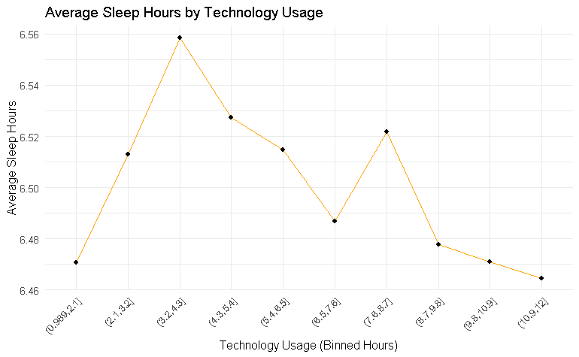

The plot shows the average sleep hours across binned ranges of daily technology usage. While there is a slight peak in sleep duration among users with 3–4 hours of technology usage, the overall pattern is relatively flat. Most groups average between 6.46 to 6.56 hours of sleep, and there are no substantial shifts that suggest increased technology usage consistently leads to more or less sleep. This visual observation suggests no clear or significant relationship between technology usage and sleep duration.

- Frequientist and Bayesian annova :
Frequentist ANOVA: A one-way ANOVA was conducted to examine whether average sleep duration differs across levels of binned technology usage. The analysis showed no statistically significant difference. This high p-value suggests that individuals in different technology usage categories (from lowest to highest usage) do not show meaningful differences in their average sleep hours. Thus, we fail to reject the null hypothesis and conclude that technology usage is not significantly associated with sleep duration based on this grouped comparison.
Bayesian ANOVA Interpretation: The Bayesian ANOVA yielded a Bayes Factor (BF₁₀) of approximately 2.9e-08, indicating overwhelming support for the null model over the alternative. In Bayesian terms, the data provide extremely strong evidence against any differences in sleep duration across technology usage levels. This reinforces the frequentist conclusion that technology usage does not appear to impact sleep hours in this sample when grouped into categories.

- Linear Regression model :
The slope coefficients for technology_Usage _Hours is -0.0045, indicating that for each additional hour technology use, sleep hours decrease by just 0.0045 hours. this effect is not statistically significant. The R-squared value is extremely low which is 0.000096 indicating which haas no predictive power at all.The effect size is negligible, not statistically significant, and the model explains almost none of the variation in sleep duration.

- Is heavy social media usage associated with reduced physical activity?
Response variable: Physical_Activity_Hours
Predictor variable: Social_Media_Usage_Hours

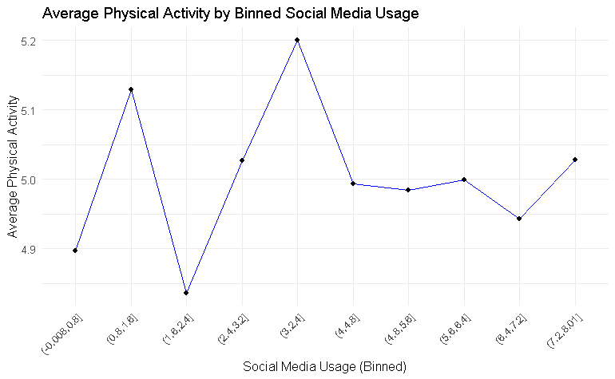

The plot shows the average physical activity hours across binned ranges of social media usage. While there are small fluctuations, the overall pattern is relatively flat, with average physical activity ranging from approximately 4.85 to 5.2 hours per day across all groups. There is no consistent upward or downward trend, and the differences between bins appear random rather than systematic. This visual observation suggests that increased social media usage is not clearly associated with reduced physical activity.

- Bayes factor :
The Bayesian correlation analysis produced a Bayes Factor of BF₁₀ = 0.024, indicating strong evidence in favor of the null hypothesis. In other words, the observed data are approximately 42 times more likely under the assumption that there is no correlation between social media usage and physical activity. This result reinforces the conclusion from the frequentist model, suggesting that social media usage is not meaningfully associated with physical activity levels in this dataset.

- Linear regression :
A simple linear regression was conducted to examine whether social media usage is associated with physical activity hours per day. The results showed no statistically significant relationship between the two variables, β = 0.0029, t(9998) = 0.23, p = 0.816. The model’s R² value was virtually zero (R² = 0.0000054), indicating that social media use explains almost none of the variation in physical activity. In short, the data do not support the idea that heavier social media usage predicts lower physical activity levels.

Access to support systems associated with better physical activity or sleep patterns?
Response variables: Physical_Activity_Hours, Sleep_Hours
Predictor variable: Support_Systems_Access
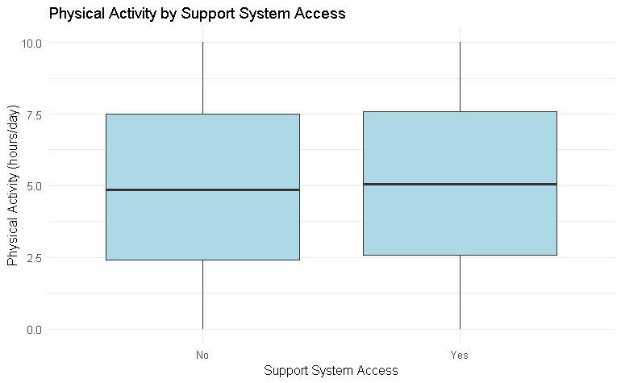
The plot displays sleep hours across groups with and without access to support systems. The median sleep duration is nearly identical for both groups (around 6.5 hours per day), and the interquartile ranges largely overlap. This suggests that support system access is not associated with a noticeable difference in sleep patterns.

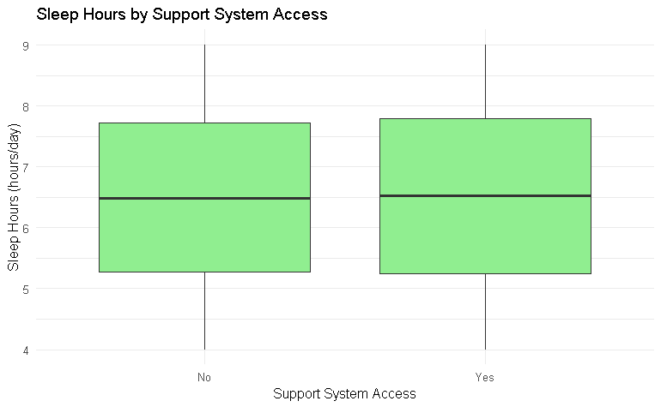
The boxplot shows physical activity levels grouped by support system access. Individuals with access to support systems display a slightly higher median activity level compared to those without. While the difference is modest, the visual suggests a potential small positive association between support access and physical activity.

- T-test for both the variables :
A T-test of physical activity by support systems shows a slight significant difference as we have a p value of 0.027 which is lower than 0.05, So it says that individuals with support systems engage in slightly more physical activities. For the other welch test sleep hours by support system both the groups with and without support systems are significantly same. and with a p value larger than 0.05 there is no statitical significant difference.he 95% confidence interval included zero, reinforcing the conclusion that support system access does not appear to significantly influence sleep duration in this sample.

- Linear regression model for both the variables :
A linear regression showed that support system access was a statistically significant predictor of physical activity, β = 0.13, t(9998) = 2.21, p = 0.027. On average, individuals with support systems engaged in 0.13 more hours of physical activity per day compared to those without access.
In contrast, the regression predicting sleep hours showed no significant effect of support system access, β = 0.028, t(9998) = 0.97, p = 0.333. The difference in average sleep duration between groups was negligible, and the model explained virtually none of the variance in sleep (R² ≈ 0.00009).
- Some Recommendations for the community leader after our analysis would be:
• Invest in local support systems such as peer groups, wellness programs, or community centers, as these showed a measurable positive impact on physical activity.
• Avoid focusing too heavily on reducing social media use unless other mental health concerns are evident, as the data did not show a strong link between usage and well-being.
• Promote balanced technology use while emphasizing community involvement and physical activity to support overall health in rural populations.

- LLM Usage Declaration
- For Research Question 1 (Gaming and Social Media Usage vs. Mental Health), I used a chatgpt to help clearly articulate my visual interpretation of the boxplots. No results or data were generated by the model.

- For Research Question 2 (Support Systems and Physical/Sleep Health), I used an chatgpt to assist in explaining the how different models will be used for physical activity and sleep prediction. The model output and interpretation were based entirely on my R analysis.

- For Research Question 3 (Screen Time and Stress Level), I used the chatgpt minimally to help clarify my ANOVA explanation, ensuring the terminology and result were described professionally. All statistical results were obtained and verified in R.

CONCLUSION
Based on the findings from this analysis, access to support systems plays a more consistent role in influencing physical activity than technology usage alone. While common assumptions often link screen time and social media with poor mental or physical health, our results showed no strong or reliable evidence supporting that narrative. Instead, the presence of social support was associated with a statistically significant increase in physical activity, highlighting the value of human connection in promoting healthier lifestyles.
Some limitations we can say from this analysis are while the dataset was large, well-structured, and free from major missing values, it lacked key contextual variables that could influence the findings. Important information such as socio-economic status, geographic location (urban vs. rural), chronic health conditions, and the specific types or purposes of technology use was not available. These data could have helped us dive deeper in the analysis for more detailed analysis, Additionally, since the data is observational and self-reported, there is potential for response bias or misreporting, especially regarding health status or screen time estimates.

ADDITIONAL RESOURCES

- Kaggle – For the dataset we used for our analysis.
https://www.kaggle.com/datasets/waqi786/mental-health-and-technology-usage-dataset

APPENDIX
- Key Plots
- Figure A1: Boxplot – Physical Activity by Support System Access
- Shows that individuals with support access engage in slightly more physical activity.
- Visually supports the t-test and regression findings indicating a meaningful difference.

- Figure A2: Line Plot – Average Sleep by Technology Usage
- Demonstrates no substantial change in sleep across increasing tech usage.
- Supports the regression result showing no significant relationship between technology use and sleep.

- Figure A3: Boxplot – Social Media Usage by Mental Health Status
- Shows similar medians and spread across all mental health groups.
- Visually reinforces the statistical conclusion that social media usage does not significantly impact mental health.

- Highlighted Statistical Results
- Physical Activity & Support Access
- T-test: p = 0.027
- Regression: β = 0.13, p = 0.027
- Interpretation: Individuals with support access are slightly more active; this is statistically significant.

- Sleep & Support Access
- T-test: p = 0.333
- Regression: β = 0.028, p = 0.333
- Interpretation: No meaningful difference in sleep duration based on support access.

- Mental Health & Tech Usage (Social Media + Gaming)
- ANOVA: p > 0.48 for both variables
- Bayes Factor: BF ≈ 0.0002–0.0003 → Strong support for no effect
- Multinomial Regression: All p-values > 0.24
- Conclusion: No statistical relationship between gaming/social media and mental health.

- Stress Level & Screen Time
- ANOVA: p = 0.20
- Bayes Factor: BF = 0.0059
- Ordinal Regression: β ≈ 0, p = 0.33
- Conclusion: No significant relationship between screen time and stress.

- Summary Table (Key variables)

Variable | Mean | Median | SD
Sleep Hours | 6.51 | 6.49 | 1.45
Physical Activity Hours | 5.00 | 5.01 | 2.91
Social Media Usage (hours) | 4.08 | 4.00 | 2.53
Gaming Hours | 2.66 | 2.58 | 2.35
Technology Usage (hours) | 4.37 | 4.13 | 2.33

- Notes on Data Cleaning
The dataset required minimal cleaning but included a few key transformations to prepare variables for analysis:
- Variable Recoding:
  - Support_Systems_Access was converted from a categorical variable ("Yes"/"No") to binary numeric (1 = Yes, 0 = No) to enable use in regression models.
  - Mental_Health_Status was transformed into an ordinal numeric scale for use in correlation and linear modeling, where required.
  - (e.g., Excellent = 1, Good = 2, Fair = 3, Poor = 4).
- Missing Data Handling:
  - No missing values were found in the key variables used for statistical analysis (Sleep_Hours, Physical_Activity_Hours, Screen_Time_Hours,Social_Media_Usage_Hours,Gaming_Ho-urs). Therefore, no imputation or row removal was necessary.
- Outlier Inspection:
  - Visual inspections using boxplots were performed for Gaming_Hours,Technology_Usage_Hours,Screen_Time_Hou-rs, and. Although some high values were noted, they fell within a realistic range and were retained to preserve the natural variability of the sample.
- Variable Type Conversions:
  - All relevant variables were confirmed to be numeric and properly formatted for use in ANOVA, regression, and Bayesian analysis.

